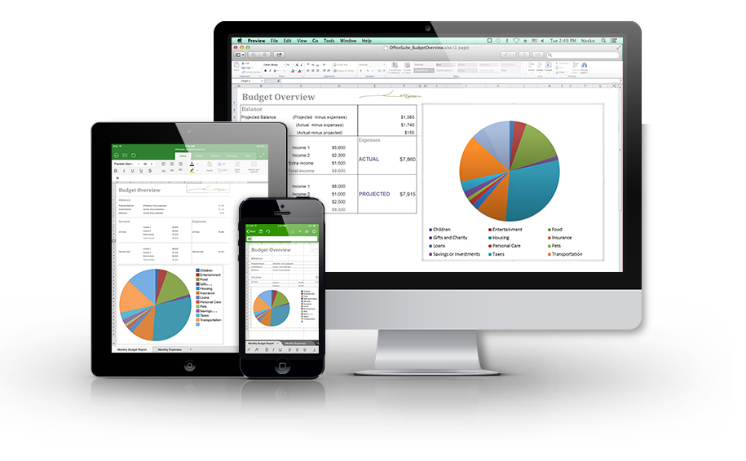

The leading productivity app is now available for Apple iPhone and iPad!
The latest version of OfficeSuite brings the power and capability of a desktop app to the iPhone and iPad like never before! This is the perfect tool for effortlessly viewing, editing, creating and sharing Documents, Spreadsheets and Presentations and converting them to/from PDFs.

What our users say about OfficeSuite:
“I’ve tried perhaps 15 different word processing apps and this is by far the best…”

“…So now it’s really easy to create Word-like docs, easy to name them and even email them (keeping the formatting – YAY)!...”

Create, view and edit Documents, Spreadsheets and Presentations files and attachments and view PDF files on your iPhone and iPad with a single complete feature-rich mobile office solution. The software accesses the most commonly used desktop document formats and also includes a File Browser and integration with iCloud, Google Drive, Dropbox, Box, OneDrive, and WebDAV to help you manage your local and remote files. OfficeSuite is essential productivity application offering greater office efficiency anywhere, anytime.

What makes OfficeSuite better?
- Extremely fast and easy to use
- Familiar desktop-inspired user interface
- Track Changes with multiple author support
- Full editor for Documents, Spreadsheets and Presentations
- Edit, annotate and save PDF documents
- View and edit RTF and CSV file formats
- Supports all Microsoft Office file formats
- Printing support
- Auto-correct while you type

Feature-rich support for all file formats
- Documents – Microsoft Office 97 to 2010 text documents –
DOC, DOCX, DOCM, RTF, TXT, LOG, and ODT
- Spreadsheets – Microsoft Office 97 to 2010 spreadsheets –
XLS, XLSX, XLSM, CSV, and ODS
- Presentations – Microsoft Office 97 to 2010 presentations –
PPT, PPTX, PPTM, PPS, PPSX, PPSM, and ODP
- Other formats – PDF, ZIP

OfficeSuite Pro and OfficeSuite Premium
Get even more from OfficeSuite with OfficeSuite Premium (available as an in-app purchase from OfficeSuite Free), and OfficeSuite Pro:
 | OfficeSuite Free | OfficeSuite Pro | OfficeSuite Premium
Documents editing and creation
Spreadsheets editing and creation
Presentations editing and creation
View PDF Files
Complete cloud support – iCloud, Dropbox, OneDrive, Google Drive, Box, or WebDAV
Support for password protected files
Print
Spell check
Documents, Spreadsheets and Presentations file templates
Track Changes with multiple author support
OpenDocument Format support: .ODS, .ODT, .ODP
Save as PDF
Save as legacy Microsoft formats: .DOC, .XLS, .PPT
Save as .CSV
Add camera photo
PDF annotations and fillable forms
Advanced formatting and review functions for spreadsheet editing
Set app passcode
Advanced PDF security – set user passwords
Convert PDF to Documents, Spreadsheets and ePub
Quick Sign for PDF documents
Font Pack with 70+ fonts

